Examples to use in class to clarify concepts for students. Will be given at the end of the lesson before the quiz to make sure that the student’s understand what they learned.
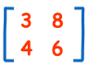
- Examples for finding the determinant of matrices:
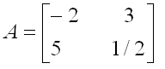

- Examples for finding minors and cofactors of matrices:
0 2 1 3 -2 4
3 -1 2 3 2 1
4 0 1 -1 3 6

- Examples for finding the determinant of a 3x3 matrix:

- Examples for triangular matrices:
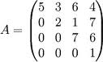
Upper Triangular:

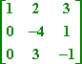
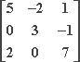

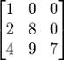
Lower Triangular:

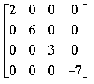
Diagonal Matrix:

